Creating a Virtual Machine in AWS
Objective
This SOP outlines the steps to create and connect to a virtual machine in AWS, ensuring team members can execute the process efficiently.
Key Steps

Step 1: Access AWS and Launch Instances 0:05
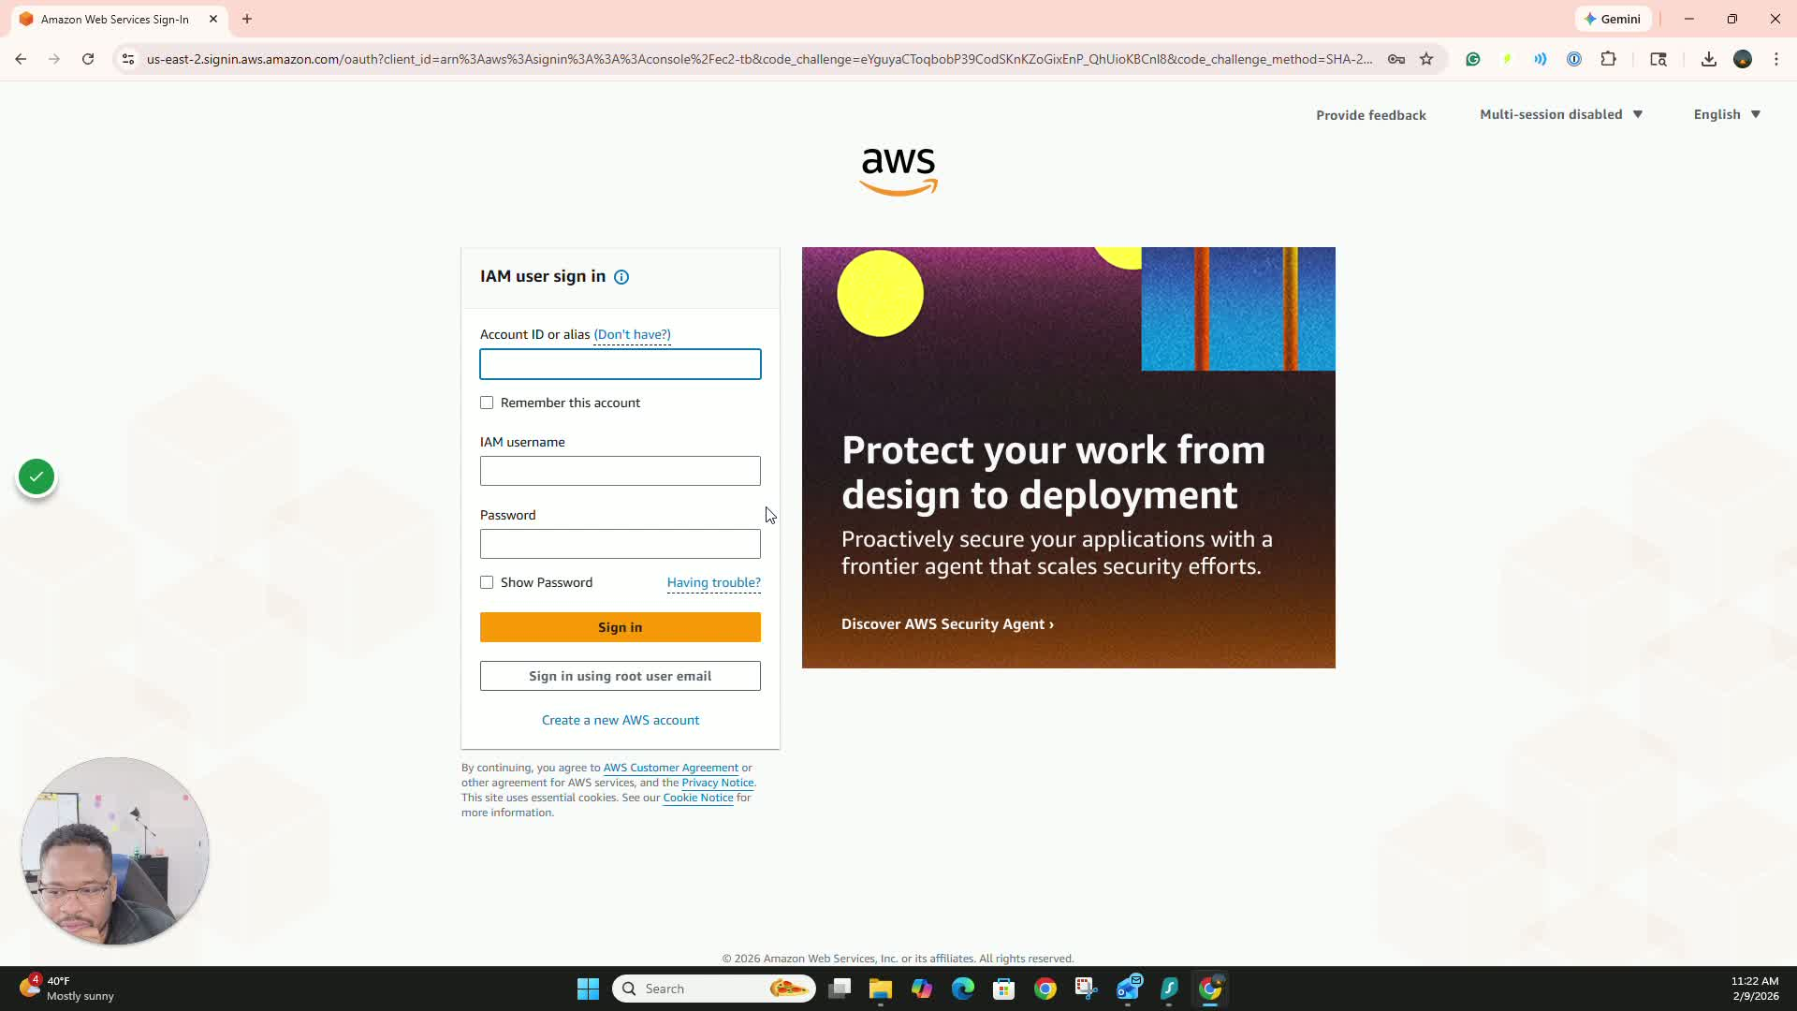
- Go to the side of the room and log in using your email.
- Wait for the dashboard to load.
- Click on 'Launch Instances' to start creating a new virtual machine.

Step 2: Configure the Virtual Machine 0:30
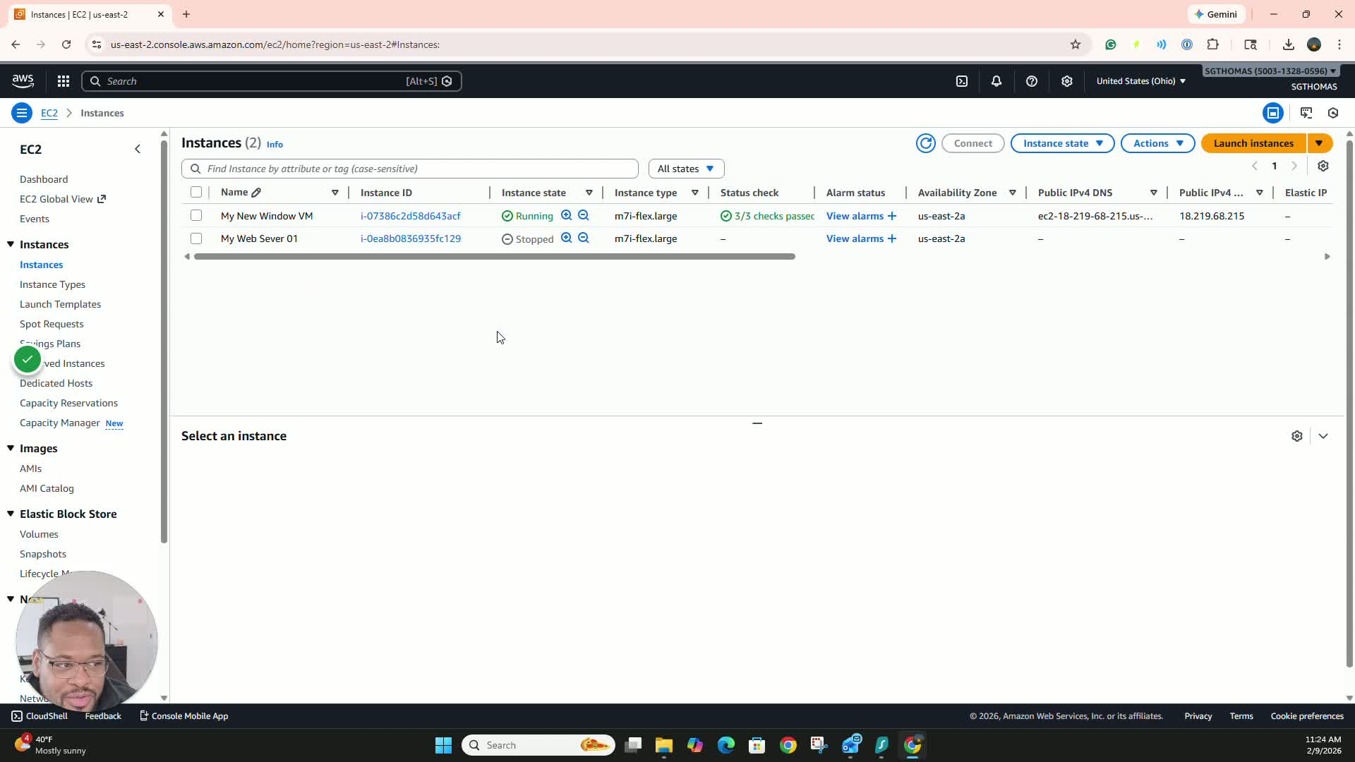
- Name your server (e.g., 'My Server 01').
- Select the type of virtual machine (choose Windows).
- Choose the instance type that fits within the free tier (e.g., 2 CPU, 8 GB memory).

Step 3: Create a Key Pair 1:25
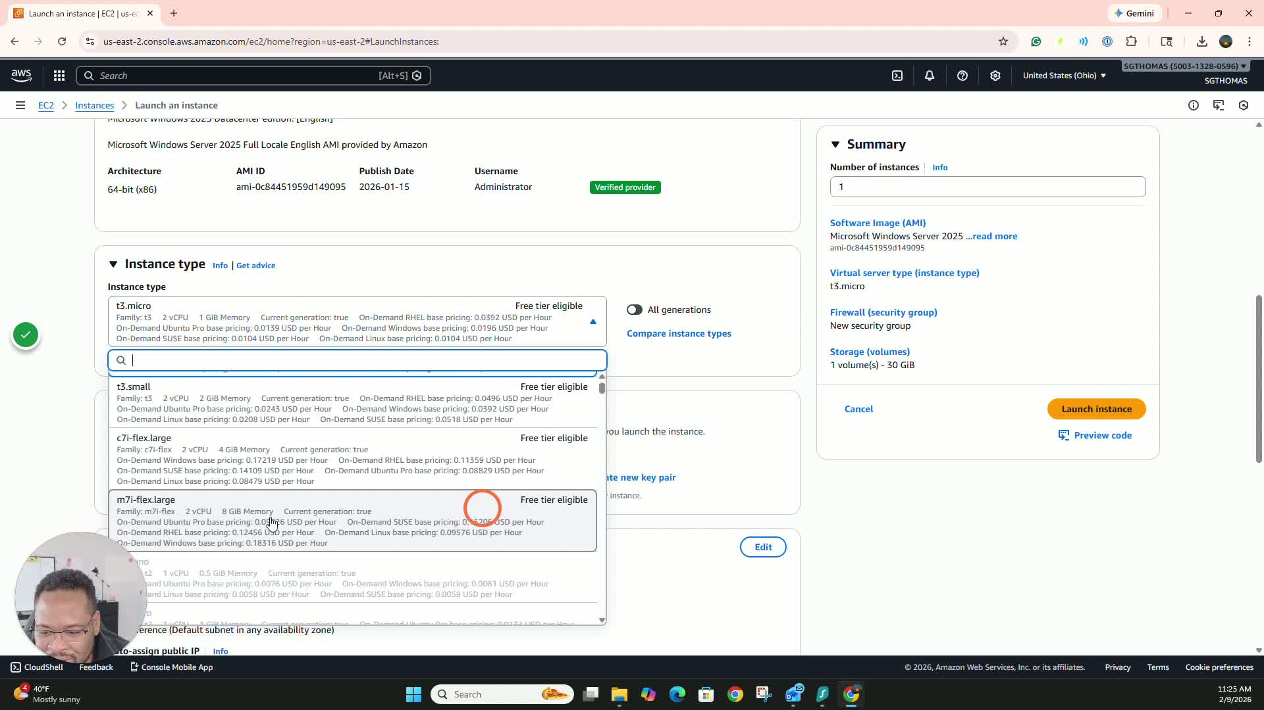
- Select 'Create Key Pair'.
- Name your key pair (e.g., 'MyServerKey01').
- Click 'Create Key Pair' and ensure to download and save the key file securely.

Step 4: Configure Network Settings 2:20
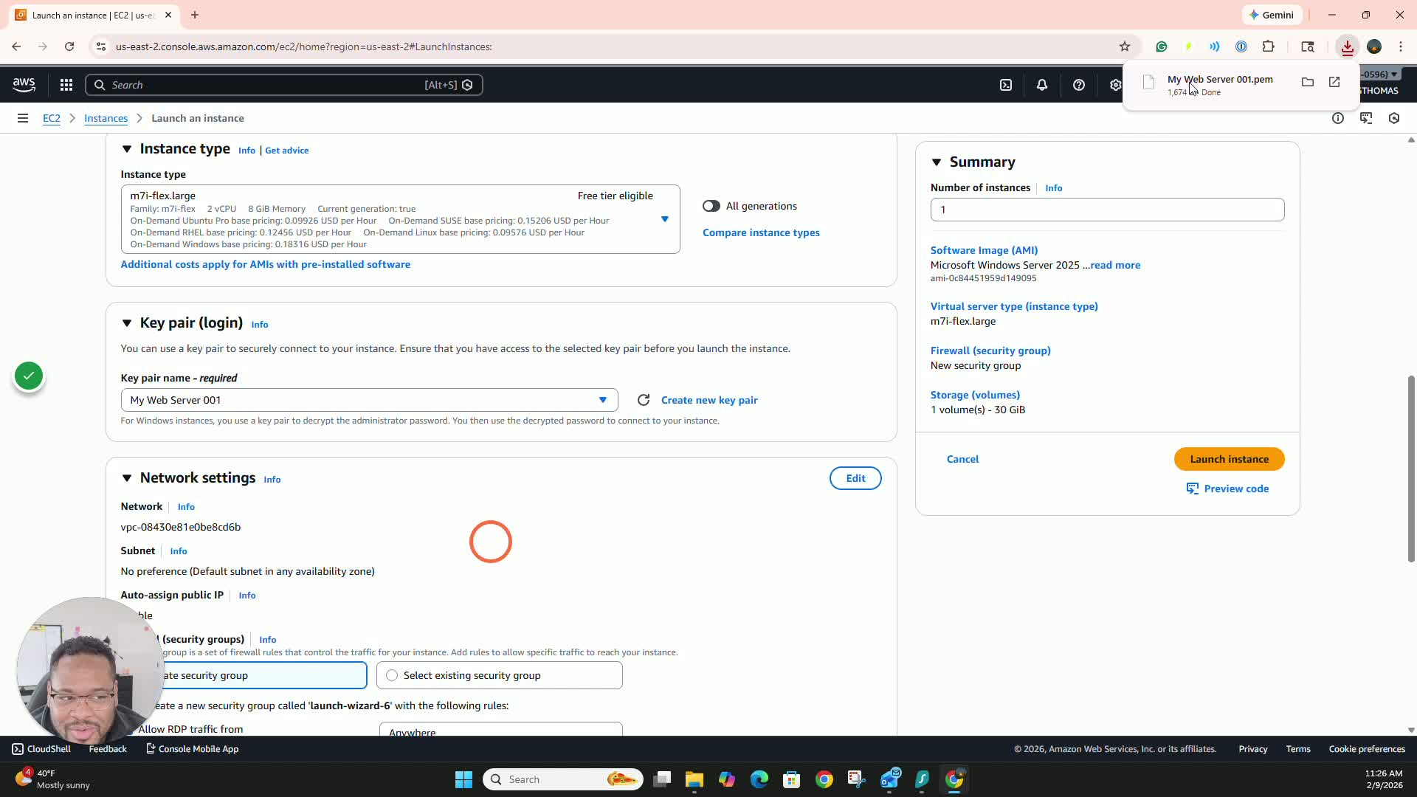
- Leave the network settings as default.
- Click 'Launch Instance' to finalize the setup.

Step 5: Monitor Instance Initialization 3:10
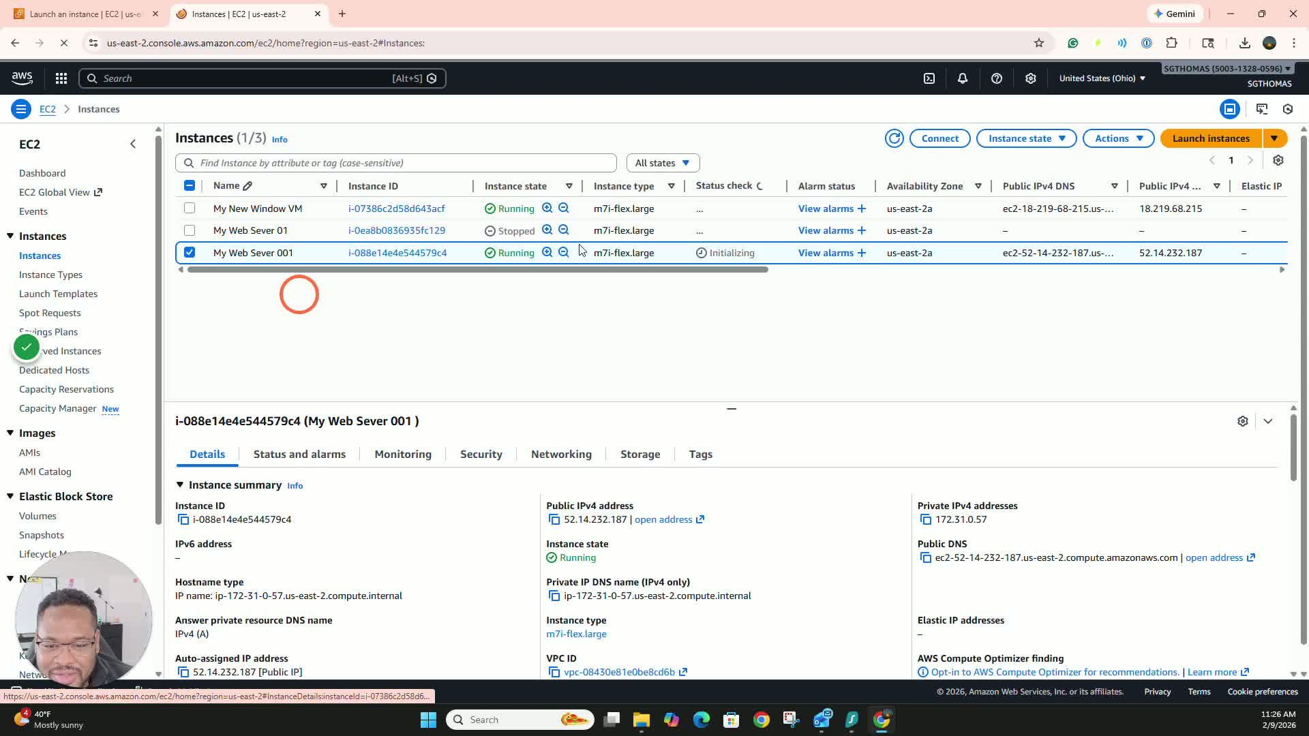
- Go to 'Instances' to check the status of your new virtual machine.
- Wait until the status shows '3 out of 3 checks passed'.

Step 6: Start the Instance 3:50
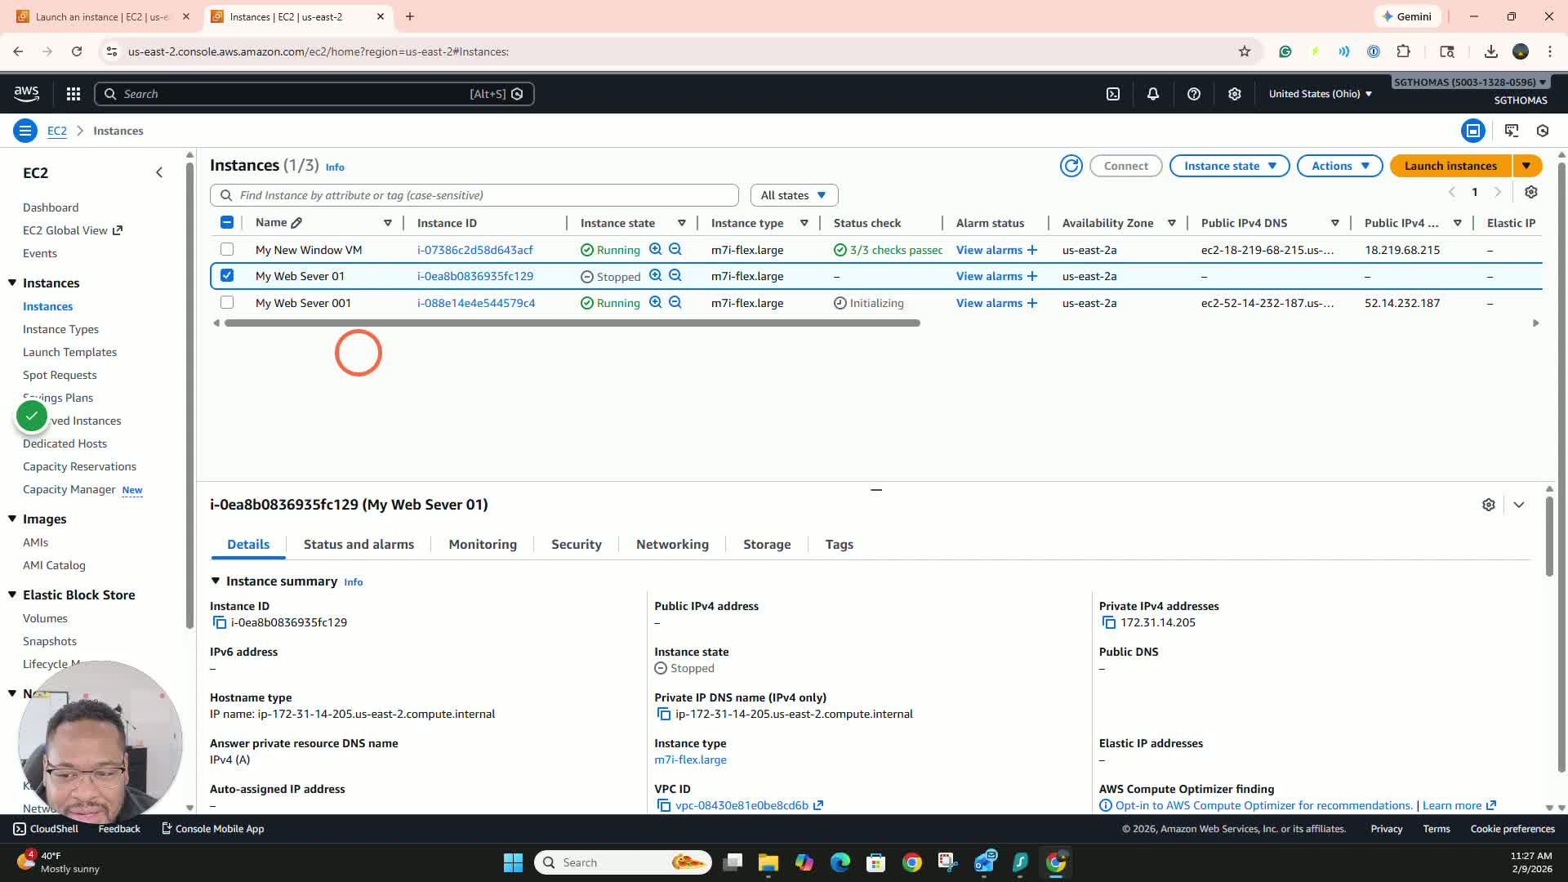
- Select your virtual machine.
- Click on 'Instance State' and then 'Start Instance'.

Step 7: Connect to the Instance 4:21
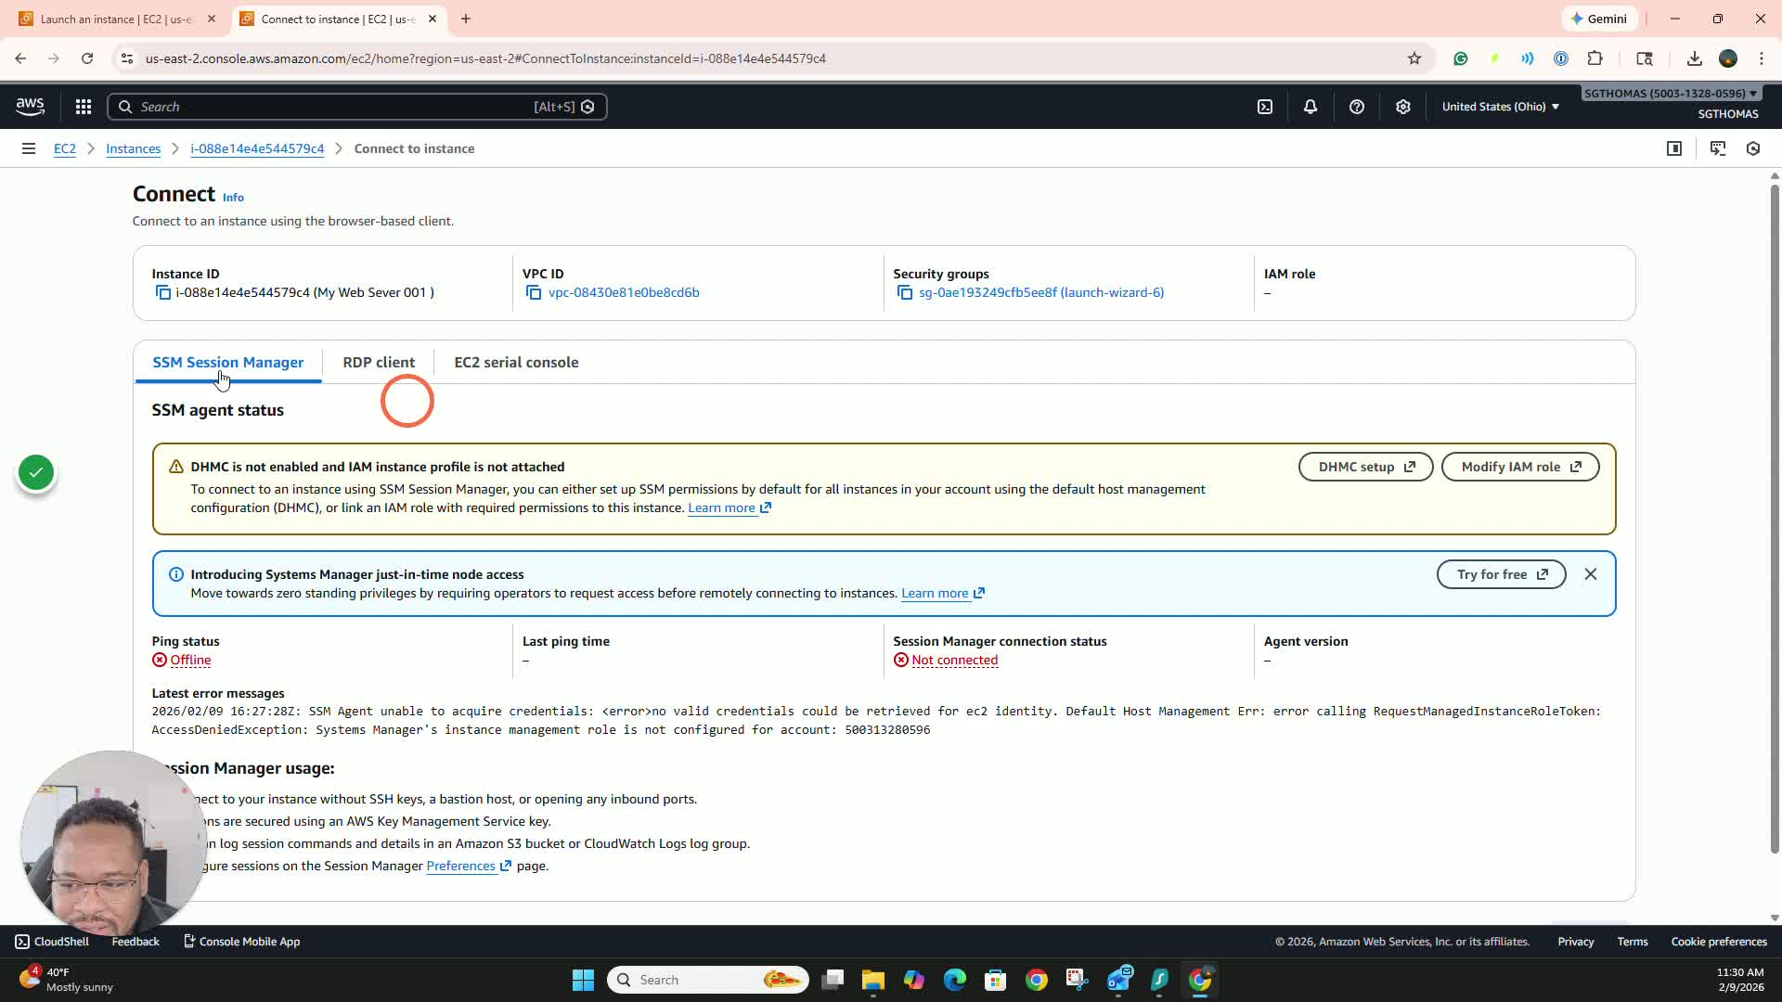
- Once the instance is running, click on 'Connect'.
- Use the RDP client to connect.

Step 8: Retrieve Password 4:41
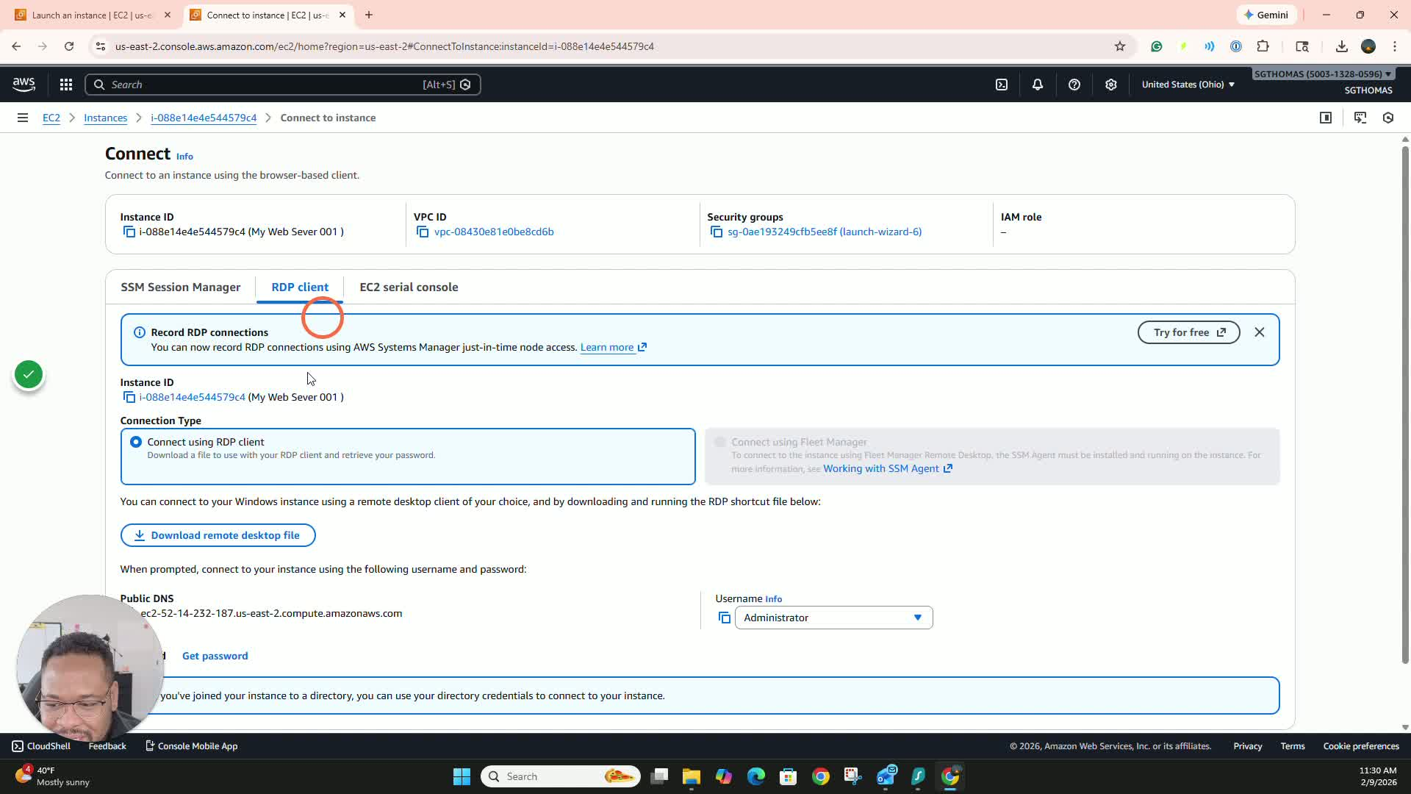
- Click on 'Get Password'.
- Upload the private key you downloaded earlier.
- Click 'Decrypt Password' and copy the generated password.

Step 9: Download Remote Desktop File 5:07
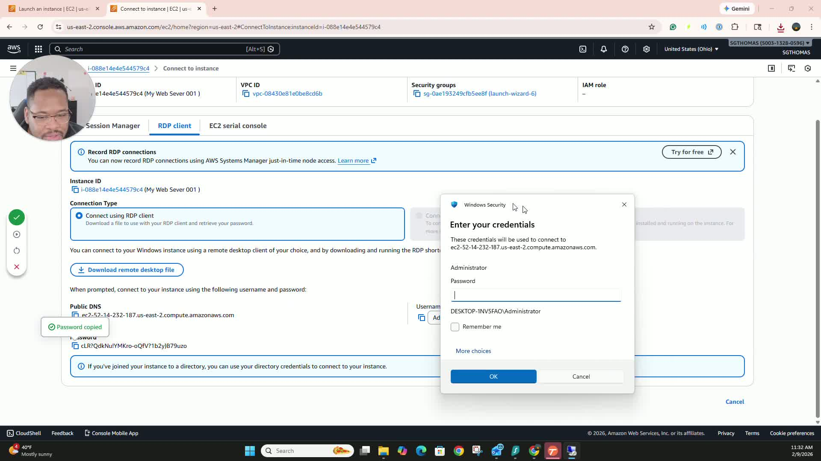
- Click on 'Download Remote Desktop File'.
- Open the downloaded file and enter the password when prompted.

Step 10: Access the Virtual Machine 5:44
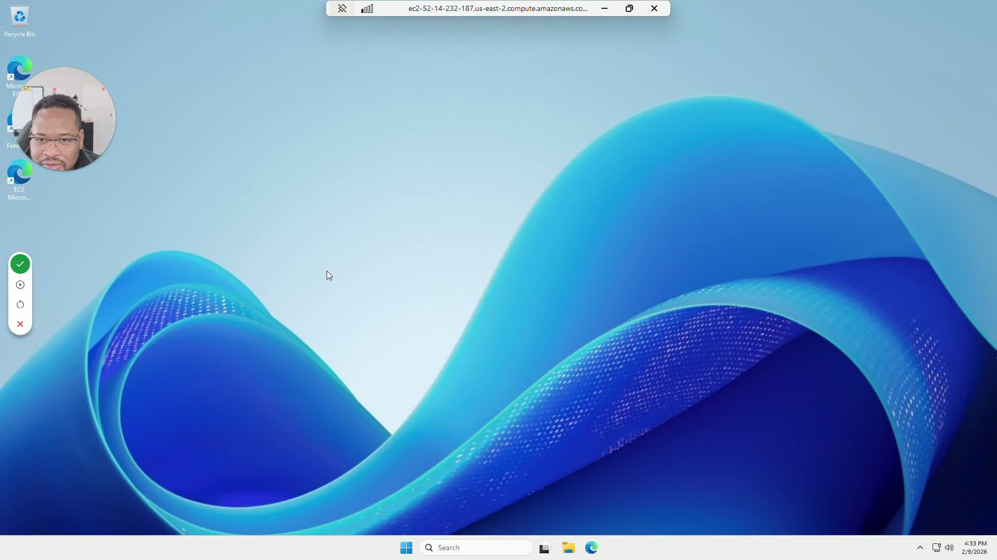
- Click 'Yes' to connect to the virtual machine.
- Once connected, you can set up applications like Active Directory.
Cautionary Notes
- Always save your key pair securely; losing it may prevent access to your virtual machine.
- Log out of your virtual machine when not in use to avoid unnecessary charges on your AWS account.
Tips for Efficiency
- Familiarize yourself with the AWS interface to speed up the process.
- Keep a record of your key pairs and instance names for easy reference.
Link to Loom
https://loom.com/share/9a034b9d77f143d18157d71631305b02

